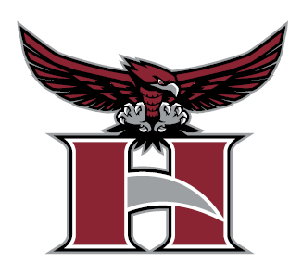

SPONSORSHIP PACKET
2023-2024
HILLGROVE SOCCER BOOSTER CLUB

December 1, 2023

Hillgrove Soccer Booster Club, Inc.
Hillgrove High School
4165 Luther Ward Road
Powder Springs, GA 30127

To whom it may concern:

We are deeply thankful to our individual and business partners for their ongoing support of the Hillgrove Soccer program. Assistance from individuals and community businesses like yours is critical to the daily operation and development of our girls’ and boys’ high school soccer programs. Your support helps to provide and pay for coaching, uniforms, equipment, transportation, game day meals, player recognition/awards and so much more to our nearly 100 girls and boys soccer student athletes!

Each year, we are tasked with the challenge of supporting and developing our program while minimizing the financial impact on our families. Because of the generous contributions of individuals and companies in our community, we can help keep participation fees low and help make Hillgrove Soccer accessible to our student athletes. We know that team sports have a tremendous impact on youth, helping to teach them the skills to succeed on the field, in the classroom, and in life. We remain committed to partnering with individuals and area businesses that share in this belief and our values, so that together we can continue to support and strengthen our student athletes, schools, and community.

Enclosed is information about Hillgrove High School and the soccer program and an overview of sponsorship opportunities available with Hillgrove Soccer. We humbly ask for your partnership for our 2024 season and thank you for your consideration. Any contribution is greatly appreciated and directly supports our student athletes, programs, school, and community.

Please do not hesitate to contact Kelly Noren at hillgrovesoccerbooster@gmail.com with questions or to learn more about the opportunities available.

With thanks and gratitude,

KELLY NOREN | SHANNON CENTER
President, Hillgrove Soccer Booster Club | Hillgrove Girls Soccer Head Coach
KETTLY MALLEBRANCHE | HEATH MERRILL
VP Girls, Hillgrove Soccer Booster Club | Hillgrove Boys Soccer Head Coach
CARRIE MORLING
VP Boys, Hillgrove Soccer Booster Club
DAWN MEYER
Treasurer, Hillgrove Soccer Booster Club
AUBREY DOSEN
Secretary, Hillgrove Soccer Booster Club | 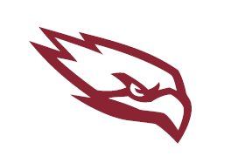

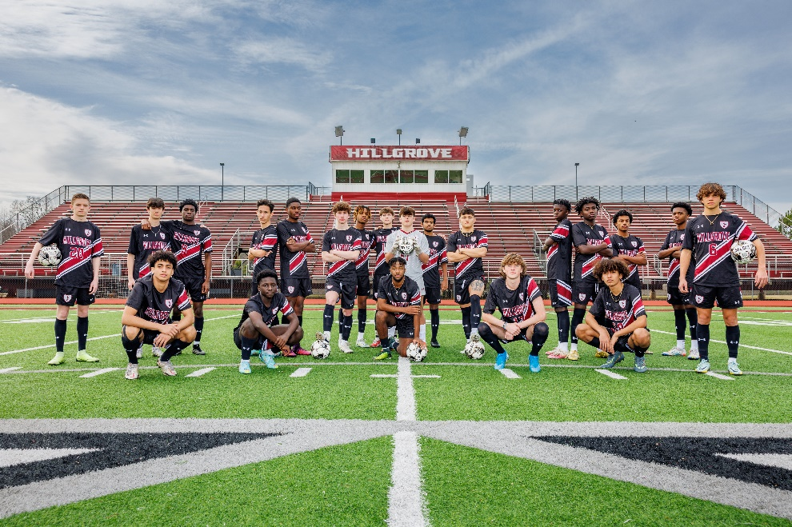
HILLGROVE
BOYS SOCCER

State Playoffs:
2007-2011, 2014, 2016-2023
State Elite 8:
2014, 2018, 2019
State Final Four:
2009, 2022
Region Champs:
2018, 2019, 2020*, 2023

MDJ Player of the Year:
Juan Carlos Pacheco (2009 and 2010)
Georgia Gatorade Player of the Year: Quin Delamater (2022)
MDJ Coach of the Year:
Heath Merrill (2019)

For more information, please visit www.hillgrovesoccer.org
HILLGROVE
GIRLS SOCCER

State Playoffs:
2009-2022*
State Elite 8:
2011, 2013, 2018, 2019
Region Champs:
2017, 2018, 2019, 2020*

MDJ Player of the Year:
Erin Carleton (2019)
MDJ Coach of the Year:
Shannon Center (2018)

GET TO KNOW US
ABOUT  HILLGROVE | Established in 2006, Hillgrove High School is a public High School Powder Springs, Georgia. Hillgrove is a part of the Cobb County School District. Hillgrove currently has over 2,000 students in grades 9–12. Angela Stewart is the current principal of the school. The motto is “Soaring toward deliberate success in academics, the arts, and athletic achievement.”
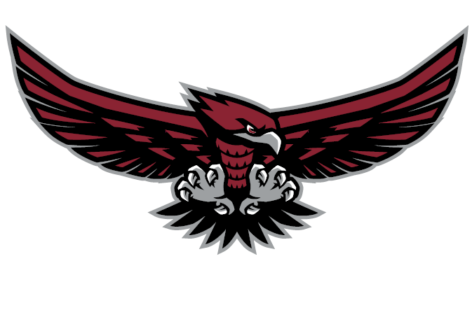
HILLGROVE  ATHLETICS | - Hillgrove High School is a member of the Georgia High School Association (GHSA) and competes in Georgia Class AAAAAAA (7A) Region 3  - Mascot: Hawks  - Colors: Crimson and Silver  - Hillgrove High School prides itself on having a wide variety of sports available to our students, with teams in 21 different sports including: Soccer, Track and Field, Baseball, Basketball, Football, Lacrosse, Cheerleading, Cross Country, Softball, Volleyball, Wrestling, Golf, Flag Football, Tennis, and Swimming.  - 850 +/- Hillgrove Athletes for all sports combined including Varsity, Junior Varsity, and freshman teams and approximately 350 additional athletes in feeder programs.  - 20,000 +/- Spectators annually for all Spring sports played in Hillgrove High School venues.  - Hillgrove’s Stadium has a seating capacity of 3,454 and is home to all four of the Hawks’ soccer teams.

HILLGROVE  SOCCER | GIRLS SOCCER  Head Coach:  Shannon Center  Started Hillgrove HS girls’ soccer program.  28 years of HS varsity coaching experience  Varsity Girls:  25 players  Junior Varsity Coach:  Jordan Ivey  Junior Varsity Girls:  25 players | BOYS SOCCER  Head Coach:  Heath Merrill  10th year as Hillgrove HS boys’ soccer head coach. 18 years of HS varsity coaching experience  Varsity Boys:  25 players  2023 REGION CHAMPS  Junior Varsity Coach:  Pierre Joseph  Junior Varsity Boys:  25 players
Important Dates:
Tryouts = week of January 15th
First regular season game = February 1st
Last regular season game = April 12th
(Varsity plays approx. 16 games; Junior Varsity plays 13 games)
State Playoffs = April 16 – May 2
State Championships = May 10

BENEFITS OF PARTNERING WITH HILLGROVE SOCCER

WHY SUPPORT HILLGROVE SOCCER?

- Brand awareness: For businesses, build brand awareness and a positive reputation among employees and customers as you support community causes and our local student athletes.

- Exposure: Exposure to 150+ active families, nearly 100 high-achieving student athletes, and over 500 members in the West Cobb area. Hillgrove soccer teams play thirty home matches in 2024 (not including playoffs) for multiple impressions.

- Community engagement: Show your commitment to the community, foster goodwill among customers, neighbors, and employees, and help strengthen our local community.

- Financial: Donations to non-profits are tax-deductible, which can lead to savings for both individuals and businesses.

FAQs

Q – Does Hillgrove High School Soccer receive funding from Cobb County?
A – No, all funds are raised by Hillgrove Soccer Booster Club through player (member) dues, and fundraising activities including sponsorships, gifts, team fundraising activities, community events, concessions, spiritwear, etc.

Q – Can athletes be excluded from playing on a team if they are unable to pay the required participation fees?
A – Every student has the right to play, regardless of their ability to pay the fees. That is one of the reasons Hillgrove relies on its sponsors and fundraising efforts, to make sure that all students who want to participate can.

Q – Does it really cost that much to operate a high school sports team?
A – Yes, various expenses associated with running a sports team include coaches’ salaries, uniforms, equipment, facility improvements, transportation, special events, game day meals, player recognition/awards, and more!

HILLGROVE SOCCER PROGRAM SPONSORSHIP OPPORTUNITIES

BRONZE: $750
- Company recognition by announcer during each home game (including all postseason home games)
- Company listing on hillgrovesoccer.org with a link to your site
- (1) social media post during the regular season on Hillgrove Soccer social channels with Company logo and description

SILVER: $1,500
- Company recognition by announcer during each home game (including all postseason home games)
- Company Logo on hillgrovesoccer.org with a link to your site
- (1) social media post during the regular season on Hillgrove Soccer social media channels with Company logo and description

GOLD: $3,000
- Company recognition by announcer during each home game (including all postseason home games)
- Company Logo on hillgrovesoccer.org with a link to your site
- (2) social media posts during the regular season on Hillgrove Soccer social media channels with Company logo and description
- Company Logo on the back of practice t-shirts for all (4) teams*
- Company Logo on the back of t-shirts for Hillgrove Alumni game (held in May)
- Company recognition by announcer during Alumni game (held in May)
*Sponsorship must be purchased before t-shirt order

PLATINUM: $5,000
- Company recognition by announcer during each home game (including all postseason home games)
- Company Logo on the homepage and sponsor page of hillgrovesoccer.org with a link to your site
- (2) social media posts during the regular season on Hillgrove Soccer social media channels with Company logo and description
- Company recognition on Jumbotron at each home game
- Company Logo on the back of practice t-shirts for all (4) teams*
- Company Logo on the back of attendee t-shirts for Hillgrove Youth Soccer Camp (held in June/July)
*Sponsorship must be purchased before t-shirt order

HILLGROVE SOCCER TEAM SPIRIT SPONSORSHIP OPPORTUNITIES
Monetary or In-Kind donations are welcome!

PRE-GAME MEAL SPONSOR: $300 (per team, per game)
Multiple opportunities available, and more than one game can be selected.
Sponsor a nutritious pre-game meal that is provided to teams and coaches for all home and away games on school days with start times of 6:00pm or before.
- Company recognition by announcer during the selected home game
- Company Logo on the sponsor page of hillgrovesoccer.org with a link to your site
- (1) post during the regular season on Hillgrove Soccer social media channels with Company logo and description
For In-Kind donations, Sponsor must be able to
- support athlete pre-game meal requirements (simple, nutritious meal for thirty persons to include appropriate main item, side, and beverage)
- order meal and deliver to the program on the selected game day by 3:15pm.
The Booster Club can provide recommendations based on past support and current needs.
The Booster Club will review and approve your proposal and coordinate game dates.
Requirements for In-Kind Donations: All in-kind donations must adhere to health and safety regulations. Please contact us to discuss specific requirements to ensure that your contribution aligns with the needs of our concession stand and Hillgrove athletic events.

SENIOR BANQUET SPONSOR: $3,000 (1 available)
Sponsor the meal and event space for athletes and coaches at our senior athlete banquet.
- Company Logo on the sponsor page of hillgrovesoccer.org with a link to your site
- (1) post during the regular season on Hillgrove Soccer social media channels with Company logo and description
- Company Logo and name on signage at the event (if at a neutral event space)

For In-Kind donations, Sponsor must be able to
- support meal requirements (meal and beverage for approx. sixty athletes and ten coaches to include main item, side, and beverage)
- provide restaurant/event space for 60-70 on a mutually agreed upon date
The Booster Club will review and approve your proposal and coordinate the date.
Requirements for In-Kind Donations: All in-kind donations must adhere to health and safety regulations. Please contact us to discuss specific requirements to ensure that your contribution aligns with the needs of our concession stand and Hillgrove athletic events.

POST-SEASON BANQUET MEAL SPONSOR: $3,000 (1 available)
Sponsor the meal provided to athletes and coaches at our post-season banquet.
- Company Logo on the sponsor page of hillgrovesoccer.org with a link to your site
- (1) post during the regular season on Hillgrove Soccer social media channels with Company logo and description
- Company Logo and name on signage at the event

For In-Kind donations, Sponsor must be able to
- support meal requirements (meal for 225 persons to include appropriate main item, side, and beverage)
- order meal and deliver to the program on the selected date and time
The Booster Club will review and approve your proposal and coordinate game dates.
Requirements for In-Kind Donations: All in-kind donations must adhere to health and safety regulations. Please contact us to discuss specific requirements to ensure that your contribution aligns with the needs of our concession stand and Hillgrove athletic events.

HILLGROVE SOCCER HOME GAME
CONCESSION STAND SPONSORSHIP OPPORTUNITIES

Monetary or In-Kind donations are welcome!
Multiple opportunities available, and more than one game can be selected.
Why sponsor Hillgrove High School Soccer concession stand? Align your brand and business with a high-performing and well-respected high school soccer program and showcase your commitment to the community. The concession stand attracts Hillgrove students before games as well as parents, fans, and students during games, ensuring maximum exposure for your business. Demonstrate your dedication to the community and showcase your brand or offering among potential customers.

SNACK SUPPORTERS CONCESSIONS SPONSOR: $100
Provide a delicious snack that concession stands are known for.
- Company/name recognition by announcer during the selected home game
- Company/name listing on the sponsor page of hillgrovesoccer.org

SWEET TREAT CHAMPIONS CONCESSIONS SPONSOR: $150
Provide a tasty, delectable dessert and be the champion of the delightful and indulgent side of our concession stand experience.
- Company/name recognition by announcer during the selected home game
- Company Logo/name on the sponsor page of hillgrovesoccer.org
- (1) post during the regular season on Hillgrove Soccer social media channels with Company logo/name and description

MAIN EVENT CONCESSIONS SPONSOR: $200
Provide a substantial main item and position your business as the culinary master behind the heart of the concession stand offering.
- Company recognition by announcer during the selected home game
- Company Logo on the sponsor page of hillgrovesoccer.org with a link to your site
- (1) post during the regular season on Hillgrove Soccer social media channels with Company logo and description
- Company Logo and name on concession stand signage

In-Kind donation opportunities:
For those businesses wishing to contribute in-kind donations, we welcome your support! In-kind donations could include:
- Food and beverage items meeting Hillgrove Soccer Booster Club and health/safety standards
- Concession stand equipment
- Concession stand supplies
The Booster Club can provide recommendations based on Hillgrove Soccer event attendance, past sales, and current needs.
The Booster Club will review and approve your proposal and coordinate game dates.
Requirements for In-Kind Donations: All in-kind donations must adhere to health and safety regulations. Please contact us to discuss specific requirements to ensure that your contribution aligns with the needs of our concession stand and Hillgrove athletic events.

FLY WITH THE HILLGROVE HAWKS SOCCER FAMILY
2023-2024 HILLGROVE HAWKS SOCCER SPONSORSHIP AGREEMENT

CONTACT INFORMATION:
Company Name:
Company Street Address:
City: | State: | Zip:
Company Website:
Contact First Name, Last Name:
Contact Phone:
Contact Email:
Signature:

I / we agree to the sponsorship package checked below and upon “payment in full” to receive the benefits described in the package.

- Please mark the Sponsorship Level
Program Sponsorship
$750 Bronze
$1,500 Silver
$3,000 Gold
$5,000 Platinum

Team Spirit Sponsorship
$300 Pre-Game Meal X (# of games)
In-Kind Pre-Game Meal X (# of games)
$3,000 Senior Banquet
In-Kind Senior Banquet
$3,000 Post-Season Banquet Meal
In-Kind Post-Season Banquet Meal
In-Kind Team Spirit Donation

Home Game Concession Stand Sponsorship
$100 Snack Supporters
In-Kind Snack Supporters
$150 Sweet Treat Champions
In-Kind Sweet Treat Champions
$200 Main Event Champions
In-Kind Main Event Champions
In-Kind Concession Donation
- Please submit your Brand Assets:

- Upload a high-resolution version of your logo, preferably .eps, as well as a transparent .png, to the Dropbox on hillgrovesoccer.org

- To showcase your Company effectively, please provide a concise, value-neutral description (maximum 100 words) that highlights key aspects of your business, products, or services. This description may be used in sponsorship materials such as our website, in-game announcements, and social media

- What are your social media handles?

- Please email this form to hillgrovesoccerbooster@gmail.com

- Please make your check payable to Hillgrove Soccer Booster Club, Inc.
Please include the appropriate Sponsor Level in the Memo.

- Please mail a copy of this form and your check to:
Hillgrove Soccer Booster Club, Inc.
Attn: Treasurer
4165 Luther Ward Rd.
Powder Springs, GA 30127

If you have any questions, please email hillgrovesoccerbooster@gmail.com

Hillgrove Soccer Booster Club, Inc. is a Non-Profit 501(c)(3) organization
EIN 77-0667910

